# 

# 

# **School of Future Tech**

# 

# **Case Study Report**

# on

## 

## **Your Case Study Title**

## by

### 

### **GROUP NO -5**

### 

Index

1. Introduction to the Case Study.
2. Case Background (Abstract).
3. Case Study Design.
4. Methods & Algorithms Technology Applied in the Problem Statement
5. Case Study Implementation Details and Snapshots.
6. Case Study Results and Conclusion.
7. References

## 1. Introduction to the Case Study

Online stock trading platforms play a crucial role in modern financial markets by enabling users to buy, sell, and monitor investments in real time. Zerodha is one of India’s leading online stock brokers, and its trading platform **Kite** is widely used due to its clean interface and efficient design.

This case study focuses on the design and development of a **frontend clone of the Zerodha Kite trading platform** using **HTML and CSS**. The objective of this project is to understand real-world user interface (UI) design, dashboard layouts, and responsive web design concepts by recreating the visual structure of a professional fintech application.

## 2. Case Background (Abstract)

### Background

Many beginners in web development find it difficult to understand how large-scale, real-world applications structure their user interfaces. Studying only small examples does not provide enough exposure to professional layouts such as dashboards, tables, and navigation systems used in fintech platforms.

### Abstract

This case study presents the design and implementation of a **frontend UI clone of Zerodha’s Kite trading platform** using HTML and CSS. The project includes multiple pages such as Homepage, Login, Dashboard, Orders, Holdings, and Funds. It demonstrates the use of modern CSS techniques like Flexbox, Grid, animations, responsive layouts, and modal popups. The project does not include backend functionality and is intended purely for educational and learning purposes.

## 3. Case Study Design

The frontend website is designed as a multi-page application with a consistent layout and professional styling. The design approach includes the following components:

### Page Structure

* Homepage with navigation bar, hero section, pricing, and footer
* Login page with centered form layout
* Dashboard page with sidebar and main content area
* Orders page displaying order history in table format
* Holdings page showing investment details and profit/loss
* Funds page displaying available margin and account details

### Layout Design

* Navigation bars are sticky for better usability
* Sidebar layout for market watch
* Main dashboard area for data visualization
* Responsive design for different screen sizes

## 4. Methods & Technologies Applied in the Case Study

### Technologies Used

* **HTML5** for structuring web pages
* **CSS3** for styling and layout
* **Flexbox** for alignment and responsive layouts
* **CSS Grid** for footer and structured sections
* **Media Queries** for mobile responsiveness
* **CSS Animations** for smooth UI effects
* **Font Awesome Icons** for visual elements
* **Google Fonts (Inter)** for professional typography

### Design Techniques

* CSS reset for consistent styling
* Hover effects and transitions for better user experience
* Modal popup using pure CSS (no JavaScript)
* Color coding for profit and loss indicators

## 5. Case Study Implementation Details and Snapshots

The implementation consists of separate HTML files for each page and a common CSS file for styling.

### Implementation Files

* index.html – Homepage
* about. Html- About page
* product.html- product page
* pricing.html – pricing page
* support.html – support page
* login.html – Login page
* dashboard.html – Trading dashboard
* orders.html – Orders page
* holdings.html – Holdings page
* funds.html – Funds page
* style.css – Centralized stylesheet

### Snapshots to Include

* Homepage layout
* Login page UI
* Dashboard with sidebar and investment summary
* Orders and holdings tables
* Funds page showing margin details

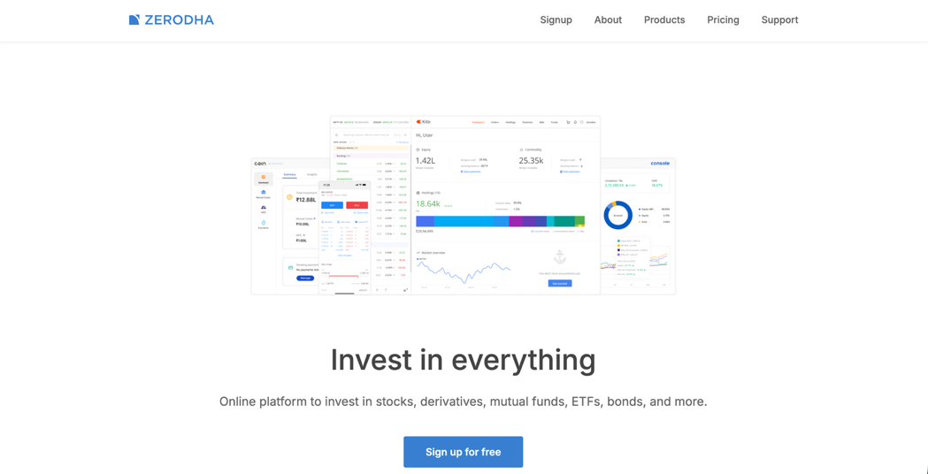

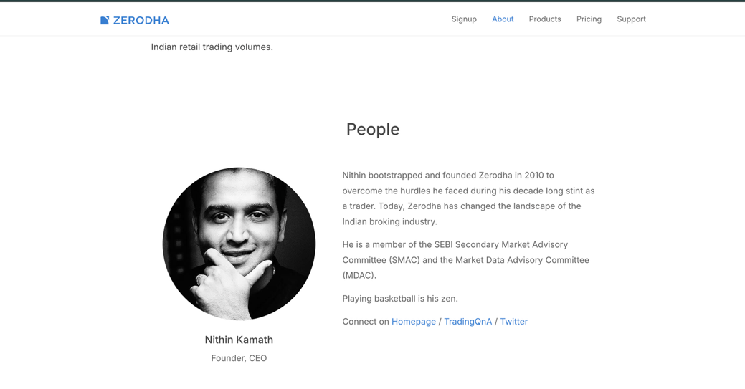

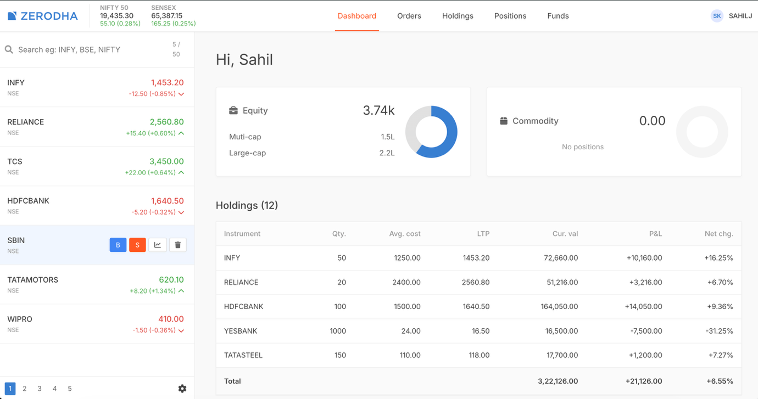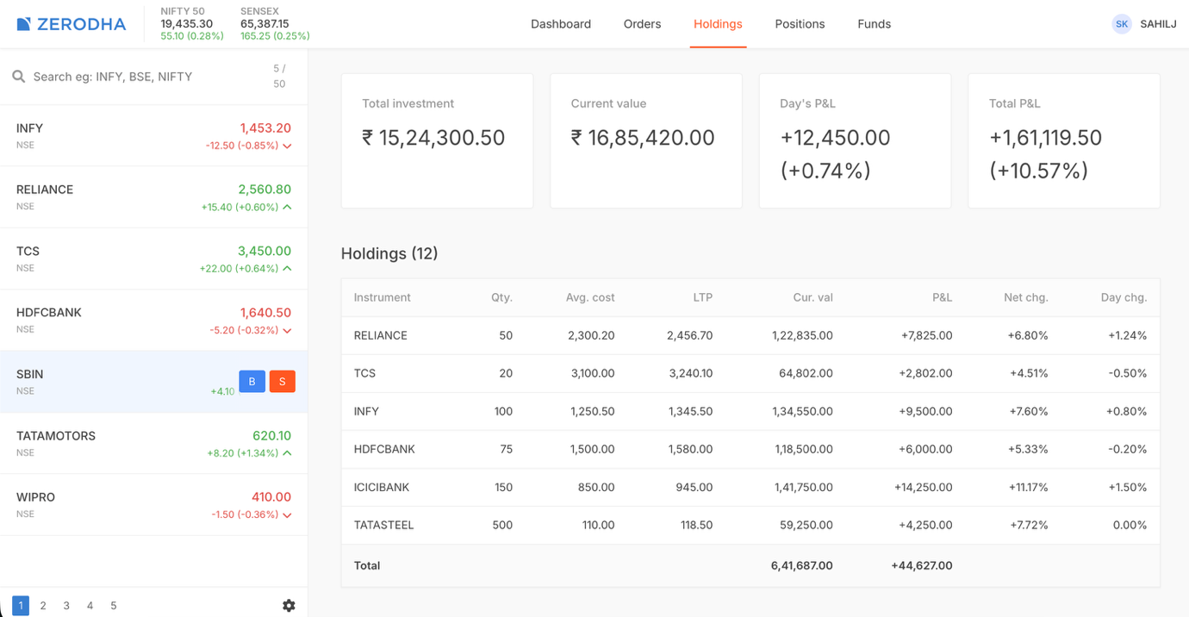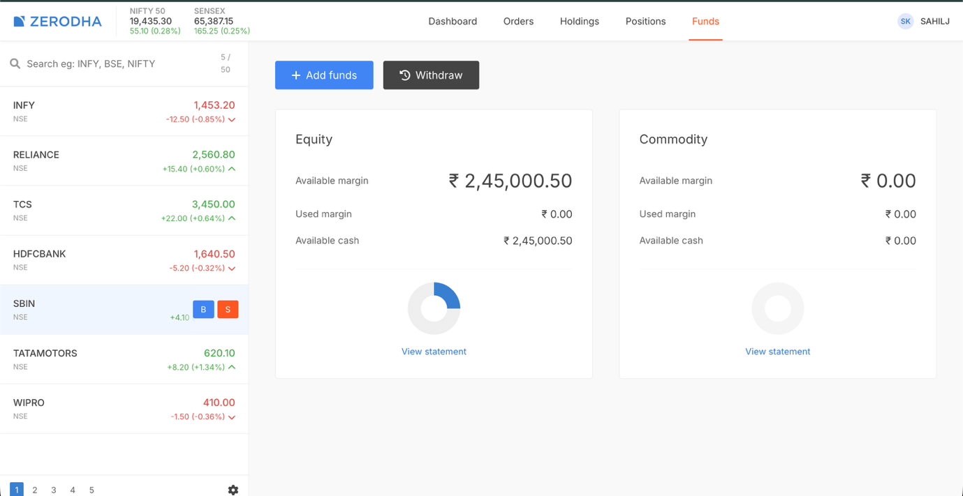

## 6. Case Study Results and Conclusion

### Results

* Successfully created a professional-looking frontend clone of Zerodha Kite
* Implemented responsive layouts suitable for desktop and mobile screens
* Achieved clean UI design similar to real trading platforms
* Improved understanding of dashboard-style web applications

### Conclusion

This case study demonstrates the practical application of HTML and CSS in building a real-world fintech user interface. By cloning the Zerodha Kite platform’s frontend, valuable experience was gained in layout design, responsiveness, and UI structuring. The project serves as a strong foundation for future enhancements such as JavaScript functionality and backend integration.

## 7. References

* Zerodha official website (UI reference)
* HTML5 and CSS3 documentation
* MDN Web Docs
* Google Fonts documentation
* Font Awesome documentation